Experiment 8

Aim: To read an image in Python and perform dilation using the dilate() function in OpenCV.

Algorithm:
- Import OpenCV and NumPy.
- Read the input image.
- Create a kernel.
- Apply dilation using cv2.dilate().
- Display the original and dilated images.
- Close all windows.

Program
import cv2
import numpy as np
img = cv2.imread("image.jpg")
kernel = np.ones((5, 5), np.uint8)
dilated = cv2.dilate(img, kernel, iterations=1)
cv2.imshow("Original Image", img)
cv2.imshow("Dilated Image", dilated)
cv2.waitKey(0)
cv2.destroyAllWindows()
Output
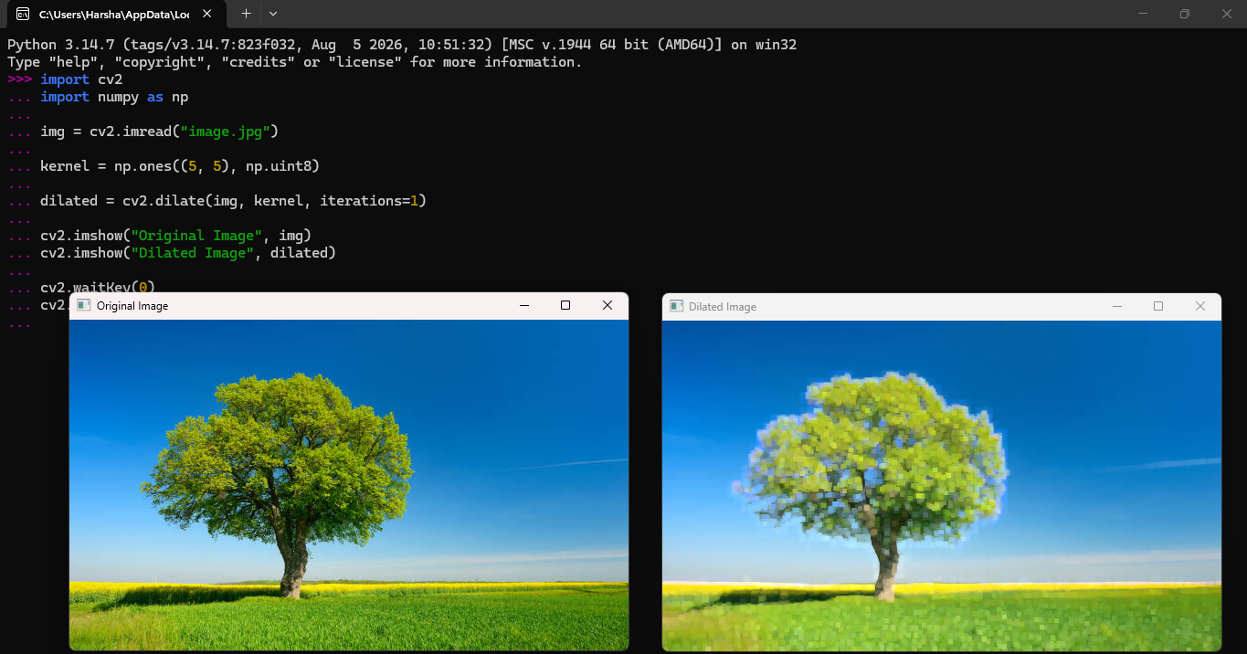

Result: Thus, the given image was successfully dilated using the cv2.dilate() function.

